Name: __________________________________ Date: _________
Period: ________ Mrs. Hatlen

Homework # ____
Industrial Business Leaders of the late 1800’s: Captains of Industry or Robber Barons?

Part I.
Directions: Read each scenario presented and answer the question that follows. Your answer should be a detailed explanation that includes references to the scenario and to your knowledge of Andrew Carnegie and the historical circumstances of this time period. Each answer should be a minimum of 5 sentences. Write your responses on a separate piece of paper or type them in a separate space.

Scenario A:
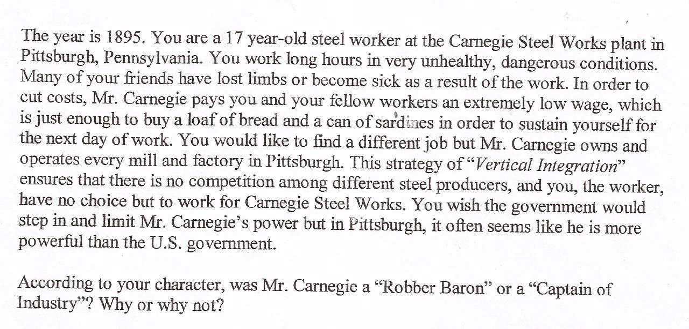

Scenario B:
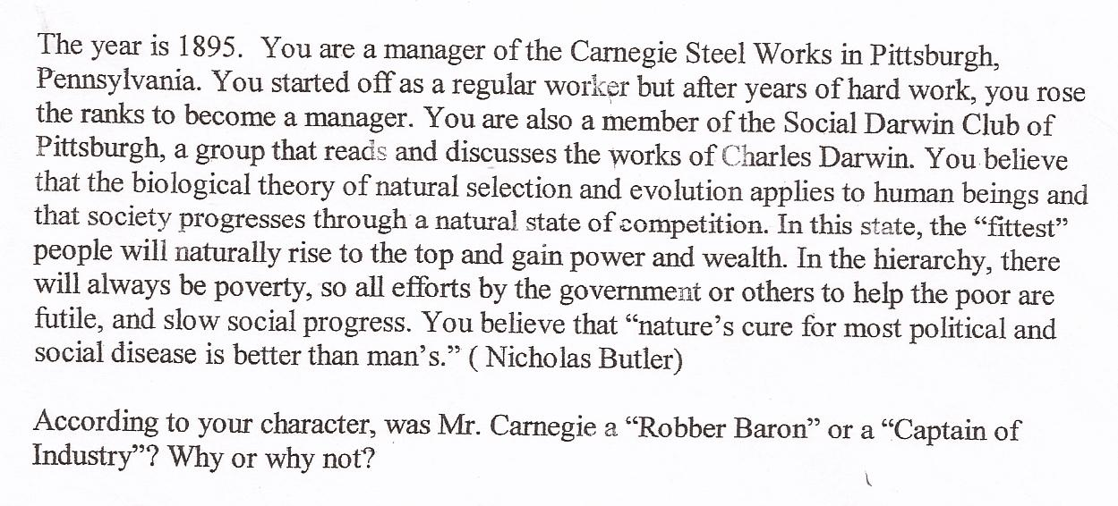

Scenario C:
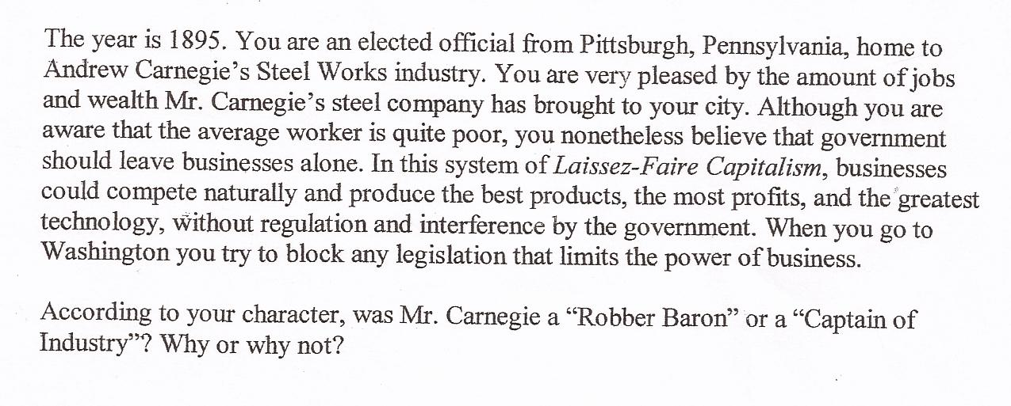
Part II.
Directions: Read each scenario presented decide if Rockefeller was a Captain of Industry or Robber Baron. Then choose THREE scenarios to write a detailed explanation that includes references to the scenario and to your knowledge of John D. Rockefeller and the historical circumstances of this time period. Each answer should be a minimum of 5 sentences. Write your responses on a separate piece of paper or type them in a separate space.



